**NAAN MUDALVAN ASSIGNMENT**

**NAME:** S.SIVANANDHINI

**DEPARTMENT**: BE BIOMEDICAL ENGINEERING

**COLLEGE**: 8151 DHANALAKSHMI SRINIVASAN INSTITUTE OF TECHNOLOGY

**NAANMUDHALVAN COURSE**: DIGITAL MARKETING

**NM ID**: BC85F20CCAEC878B36C402DEAE255EA8

ASSIGNMENT 1:

Create a blog or website using Blogspot and word press. Customize the theme design and post new article with 500 words.

BLOGSPOT URL: <https://nancysupermarket.blogspot.com/>

WORD PRESS URL: <https://wordpress.com/view/nancysupermarket.wordpress.com>

ASSIGNMENT 2:

Create a new Facebook business page and post one social media poster for your brand.

URL: <https://www.facebook.com/nancysupermarket?mibextid=ZbWKwL>

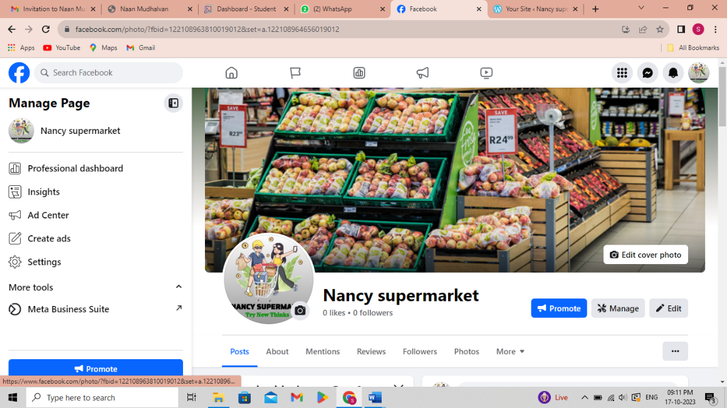

ASSIGNMENT 3:

Create and design a advertisement poster using Canva.

URL: <https://www.facebook.com/photo/?fbid=122108963810019012&set=a.122108964656019012>

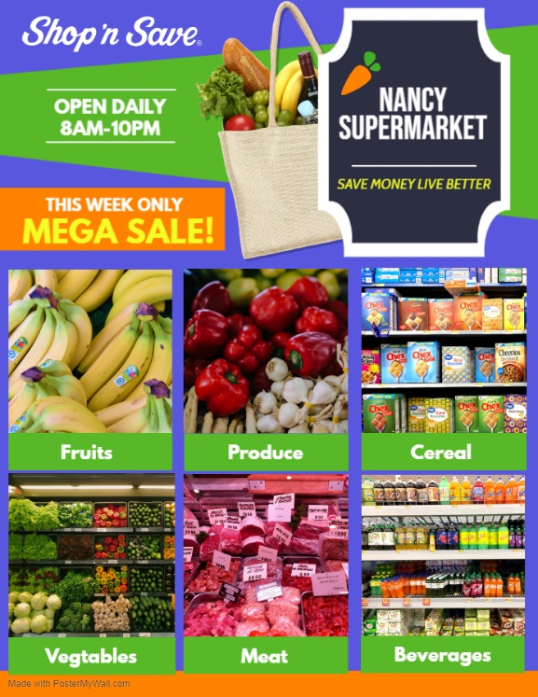

ASSIGNMENT 4:

Create an E mail newsletter design using Mailchimp or Canva tool.

URL: <https://nancysupermarket.blogspot.com/2023/09/nancy-supermarket-email-newsletter.html>

